MAUNDY THURSDAY
April 18, 2019
THE HOLY EUCHARIST: RITE II – 7:00 P.M.
The Service begins on page 274 of The Book of Common Prayer.
Prelude: Le banquet celeste Olivier Messiaen (1908-1992)
THE WORD OF GOD
Introit Nos autem gloriari Plainsong
But as for us, it behoveth us to glory in the Cross of our Lord Jesus Christ: In whom is our salvation, our life, and resurrection; by whom we were saved and obtained our freedom. God be merciful to us and bless us: and show us the light of his countenance, and be merciful unto us.
– Galatians 6:14, Ps. 67
Hymn 379: “God is Love, let heaven adore him” Abbot’s Leigh, stand
Opening Sentences
Priest: Bless the Lord who forgives all our sins.
People: God’s mercy endures for ever. Amen.
The Collect for Purity
Priest: Almighty God, to you all hearts are open, all desires known, and from you no secrets are hid: Cleanse the thoughts of our hearts by the inspiration of your Holy Spirit, that we may perfectly love you, and worthily magnify
your holy Name; through Christ our Lord. Amen.
Kyrie Communion Service in E, “Collegium Regale”
Kyrie eleison. Lord, have mercy. Harold Darke (1888–1976)
Christe eleison. Christ, have mercy.
Kyrie eleison. Lord, have mercy.

The Collect of the Day
Priest: The Lord be with you.
People: And also with you.
Priest: Let us pray.
Almighty Father, whose dear Son, on the night before he suffered, instituted the Sacrament of his Body and Blood: Mercifully grant that we may receive it thankfully in remembrance of Jesus Christ our Lord, who in these holy mysteries gives us a pledge of eternal life; and who now lives and reigns with you and the Holy Spirit, one God, for ever and ever.
People: Amen.
The Lessons
Lector: A Reading from The Book of Exodus. (12: 1-14) sit
The Lord said to Moses and Aaron in the land of Egypt: This month shall mark for you the beginning of months; it shall be the first month of the year for you. Tell the whole congregation of Israel that on the tenth of this month they are to take a lamb for each family, a lamb for each household. If a household is too small for a whole lamb, it shall join its closest neighbor in obtaining one; the lamb shall be divided in proportion to the number of people who eat of it. Your lamb shall be without blemish, a year-old male; you may take it from the sheep or from the goats. You shall keep it until the fourteenth day of this month; then the whole assembled congregation of Israel shall slaughter it at twilight. They shall take some of the blood and put it on the two doorposts and the lintel of the houses in which they eat it. They shall eat the lamb that same night; they shall eat it roasted over the fire with unleavened bread and bitter herbs. Do not eat any of it raw or boiled in water, but roasted over the fire, with its head, legs, and inner organs. You shall let none of it remain until the morning; anything that remains until the morning you shall burn. This is how you shall eat it: your loins girded, your sandals on your feet, and your staff in your hand; and you shall eat it hurriedly. It is the passover of the Lord. For I will pass through the land of Egypt that night, and I will strike down every firstborn in the land of Egypt, both human beings and animals; on all the gods of Egypt I will execute judgments: I am the Lord. The blood shall be a sign for you on the houses where you live: when I see the blood, I will pass over you, and no plague shall destroy you when I strike the land of Egypt. This day shall be a day of remembrance for you. You shall celebrate it as a
festival to the Lord; throughout your generations you shall observe it as a
perpetual ordinance.
The Word of the Lord.
People: Thanks be to God.
Psalm 116: 1, 10-17
1 I love the Lord, because he has heard the voice of my supplication,
because he has inclined his ear to me whenever I called upon him.
10 How shall I repay the Lord for all the good things he has done for me?
11 I will lift up the cup of salvation and call upon the Name of the Lord.
12 I will fulfill my vows to the Lord in the presence of all his people.
13 Precious in the sight of the Lord is the death of his servants.
14 O Lord, I am your servant;
I am your servant and the child of your handmaid; you have freed me
from my bonds.
15 I will offer you the sacrifice of thanksgiving and call upon the Name of the
Lord.
16 I will fulfill my vows to the Lord in the presence of all his people,
17 In the courts of the Lord’s house, in the midst of you, O Jerusalem.
All: Glory to the Father, and to the Son, and to the Holy Spirit;
as it was in the beginning, is now, and will be forever. Amen.
Hymn 581: “Where charity and love prevail” Cheshire, stand
Priest: The Holy Gospel of our Lord Jesus Christ according to John.
(13: 1-17, 31-35)
People: Glory to you, Lord Christ.
Now before the festival of the Passover, Jesus knew that his hour had come to depart from this world and go to the Father. Having loved his own who were in the world, he loved them to the end. The devil had already put it into the heart of Judas son of Simon Iscariot to betray him. And during supper Jesus, knowing that the Father had given all things into his hands, and that he had come from God and was going to God, got up from the table, took off his outer robe, and tied a towel around himself. Then he poured water into a basin and began to wash the disciples’ feet and to wipe them with the towel that was tied around him. He came to Simon Peter, who said to him, “Lord, are you going to wash my feet?” Jesus answered, “You do not know now what I am doing, but later you will understand.” Peter said to him, “You will never wash my feet.” Jesus answered, “Unless I wash you, you have no share with me.” Simon Peter said to him, “Lord, not my feet only but also my hands and my head!” Jesus said to him, “One who has bathed does not need to wash, except for the feet, but is entirely clean. And you are clean, though not all of you.” For he knew who was to betray him; for this reason he said, “Not all of you are clean.” After he had washed their feet, had put on his robe, and had returned to the table, he said to them, “Do you know what I have done to you? You call me Teacher and Lord—and you are right, for that is what I am. So if I, your Lord and Teacher, have washed your feet, you also ought to wash one another’s feet. For I have set you an example, that you also should do as I have done to you. Very truly, I tell you, servants are not greater than their master, nor are messengers greater than the one who sent them. If you know these things, you are blessed if you do them. Now the Son of Man has been glorified, and God has been glorified in him. If God has been glorified in him, God will also glorify him in himself and will glorify him at once. Little children, I am with you only a little longer. You will look for me; and as I said to the Jews so now I say to you, ‘Where I am going, you cannot come.’ I give you a new commandment, that you love one another. Just as I have loved you, you also should love one another. By this everyone
will know that you are my disciples, if you have love for one another.”
Priest: The Gospel of the Lord.
People: Praise to you, Lord Christ.
The Sermon: The Reverend Joseph Wallace-Williams sit
Prayers of the People
Lector: On this holy night we dine together as the body of Christ, and at the table come to love and serve one another. On this holy night, then, let us pray for
the church and the world, saying: Lord, in your mercy, hear our prayer.
kneel
For the whole church of God, that it may grow in unity and servanthood. Lord, in your mercy:
People: hear our prayer.
Lector: For our congregation, that in these holy days we may grow in love for one another and for all people. Lord, in your mercy:
People: hear our prayer.
Lector: For those who will be baptized at Easter, that they may rejoice in their passage through death into new life. Lord, in your mercy:
People: hear our prayer.

Lector: For all the leaders and people of the world, that reconciliation and peace may overcome conflict and oppression. Lord, in your mercy:
People: hear our prayer.
Lector: For the hungry in body or spirit, that they may be fed. Lord, in your mercy:
People: hear our prayer.
Lector: For the sick and those in pain, for the lonely and the forgotten, for the dying and all who mourn, that they may know the full extent of God’s love for them. Lord, in your mercy:
People: hear our prayer.
Lector: In thanksgiving for the saints and martyrs and for all the faithful departed who join us at your table of grace. Lord, in your mercy:
People: hear our prayer.
Priest: O God, into your love we commend ourselves and all for whom we pray, through Jesus Christ our Lord.
All: Amen.
Priest: Let us confess our sins against God and our neighbor.
All: Most merciful God, we confess that we have sinned against you in thought, word, and deed, by what we have done, and by what we have left undone. We have not loved you with our whole heart; we have not loved our neighbors as ourselves. We are truly sorry and we humbly repent. For the sake of your Son Jesus Christ, have mercy on us and forgive us; that we may delight in your will, and walk in your ways, to
the glory of your Name. Amen.
The Absolution
Priest: Almighty God have mercy on you, forgive you all your sins through our Lord Jesus Christ, strengthen you in all goodness, and by the power of the Holy Spirit keep you in eternal life.
All: Amen.
Exchanging the Peace stand
Announcements sit

THE HOLY COMMUNION
All baptized persons are invited to receive Communion.
If you would like to receive gluten-free bread, let the priest know at the altar rail.
At the Offertory, Motet Anton Bruckner (1824–1896)
Christus factus est pro nobis obediens  usque ad mortem, mortem autem crucis.  Propter quod et Deus exaltavit illum  et dedit illi nomen, quod est super omne nomen. | Christ for us became obedient  unto death, even the death of the cross.  Wherefore God also hath highly exalted him  and given him a name which is above every name.
–Gradual for Maundy Thursday
The Presentation Mass in E, Jeffrey Smith (b. 1960), stand
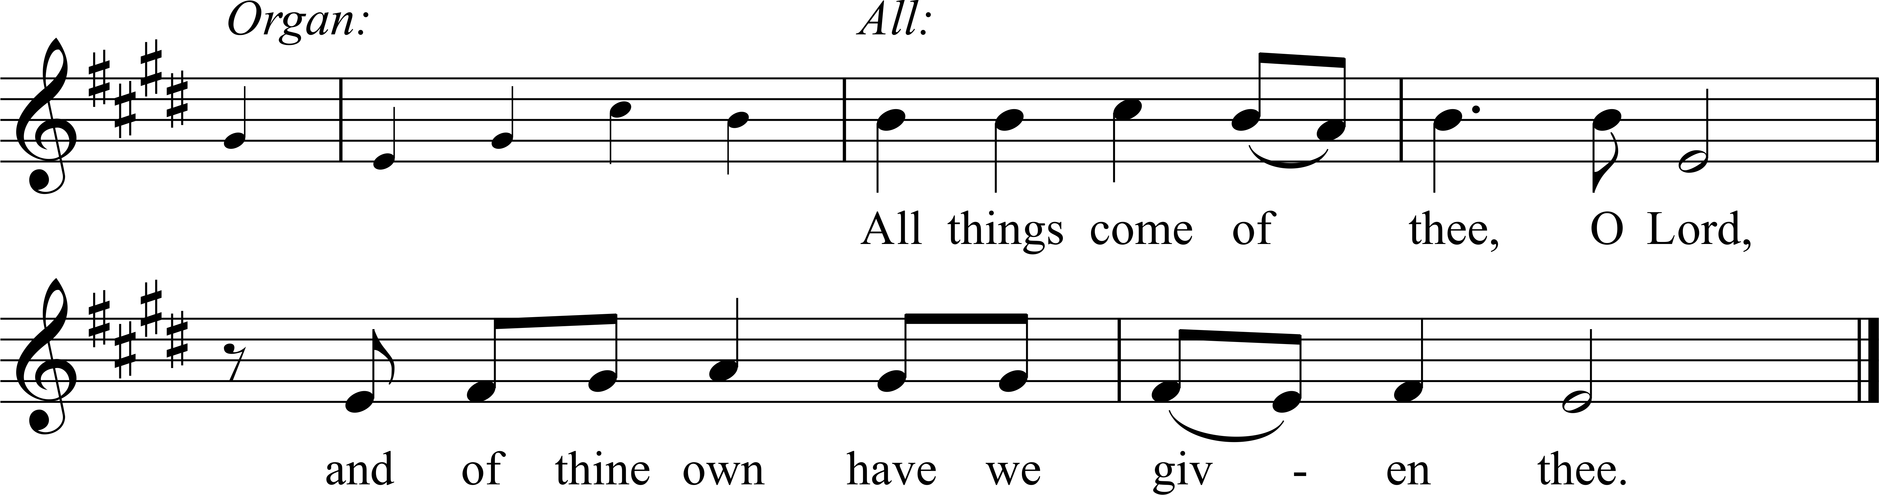
Choir: Present yourselves as a living sacrifice, holy and acceptable to God,
which is your spiritual worship.
All: All things come of thee, O Lord, and of thine own have we given thee.

The Great Thanksgiving: Eucharistic Prayer A p. 361

Sanctus and Benedictus Mass in E, Jeffrey Smith
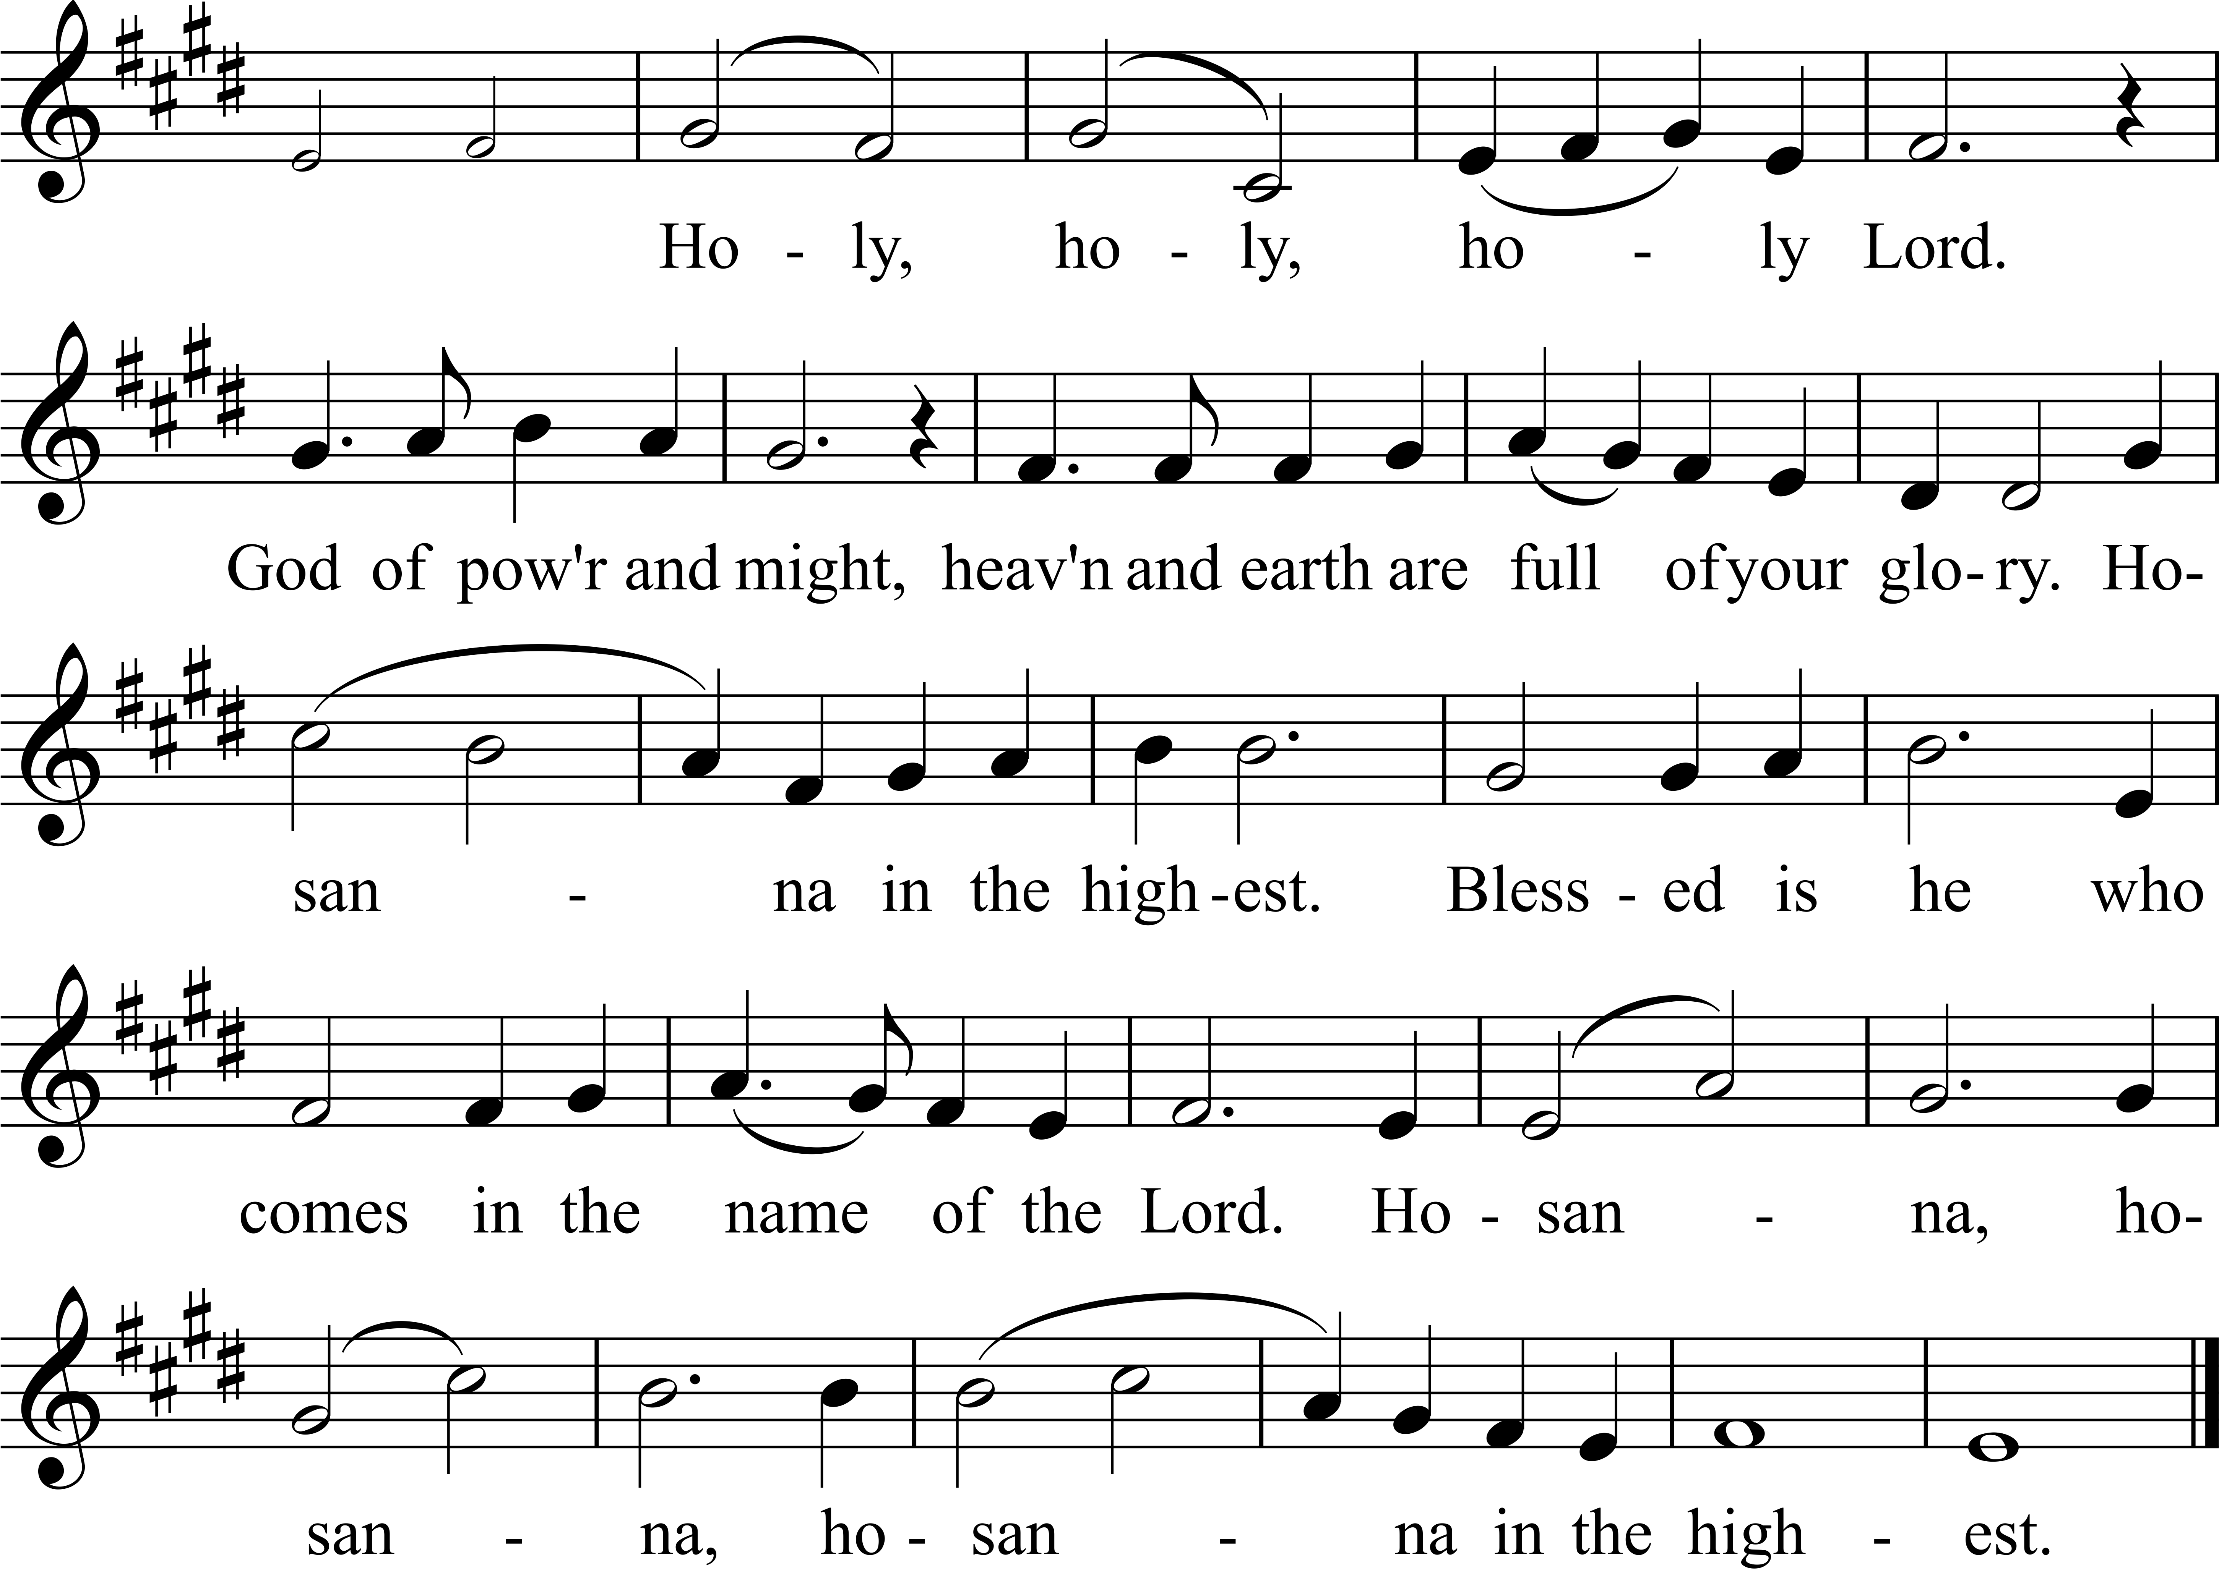
kneel
The Lord’s Prayer p. 364
Breaking of the Bread, Agnus Dei (Hymnal S 158) Healey Willan (1880–1968)
O Lamb of God, that takest away the sins of the world, have mercy upon us.
O Lamb of God, that takest away the sins of the world, have mercy upon us.
O Lamb of God, that takest away the sins of the world, grant us thy peace.
Administration of the Sacrament sit
Hymn 331: “Now, my tongue, the mystery telling” Grafton
A Prayer of Thanksgiving p. 365, kneel
The Solemn Stripping of the Altar
Psalm 69 with Antiphon Plainsong
They gave me gall to eat, and when I was thirsty, they gave me vinegar to drink.
The words of the psalm are found in The Book of Common Prayer, page 679.
Procession (in silence) stand
Tonight
There will be a prayer vigil in Grace Chapel tonight beginning immediately after this Service, until Noon tomorrow. All are welcome to spend some time in quiet prayer. The west side door will be unlocked overnight.

Good Friday
12 Noon Liturgy of the Day
4:30 p.m. Children’s Chapel with Stations
Please meet in the Undercroft.

EASTER SUNDAY SCHEDULE

6:00 a.m. Holy Eucharist in the Garden
7:30, 9:00 and 11:00 a.m. Holy Eucharist in the Church

On Easter Sunday child care will be available in the Little Building for infants through
5-year-olds from 7:30 a.m. through 12:30 p.m. Sunday School will not meet. Additional parking will be available at MICDS.

A special Easter breakfast will be served in the Undercroft 8:15-10:30 a.m.

The Easter Offering will support the mission of our ministry partners—Beyond Housing, Bravely, Episcopal City Mission, The Haven of Grace and Outreach Haiti. Please use the offering envelopes which will be in the pews on Easter Day if you wish to support these ministries in our community.

